**Onit Project: Google Search**

**Description**:

This project is created in SpecFlow/Selenium C# using BDD framework in Visual Studio 2019.

**Steps to Execute/Run:**

Test->Test Explorer->Run all Test or

Right click on project title and Run Test

**Sample screenshot of execution:**

Feature file

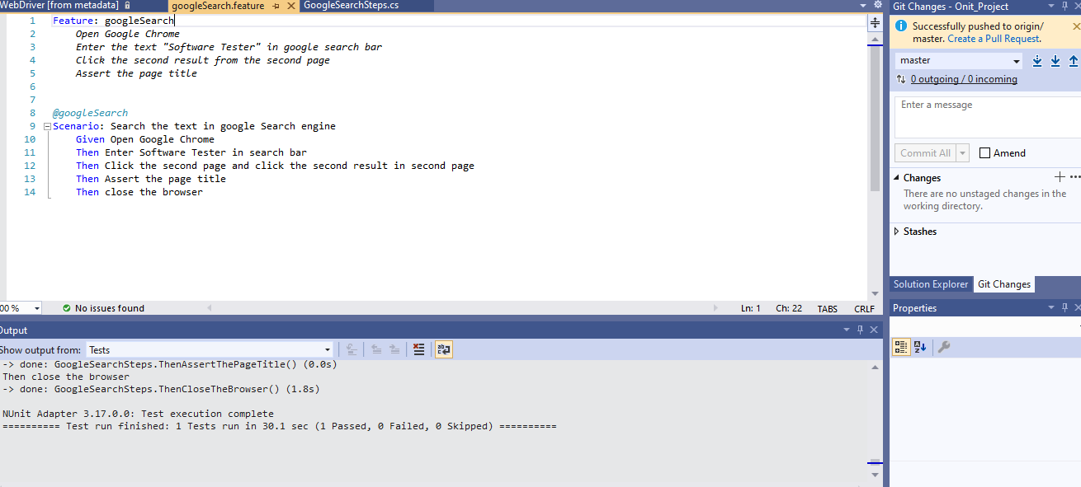

Code .cs file

Output Result:

